**case study : create an rds instance... and create a database in it .. and then create a table in it … an insert a few records into that table.....**

**GO TO RDS:**

**CLICK ON DB INSTANCES:**

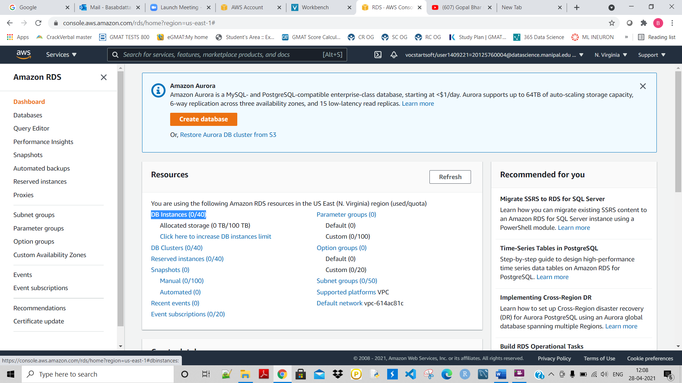

**CLICK ON CREATE DATABASE:**

**THEN SELECT STANDARD CRAETE AND SELECT MySQL, Free tier, give the credentials, select the** Burstable classes (includes t classes),

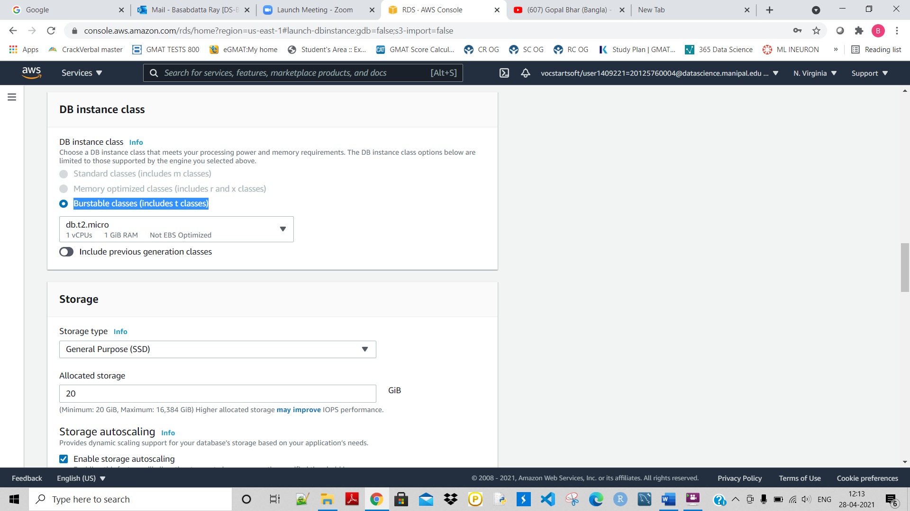

**Givr public access as yes:**

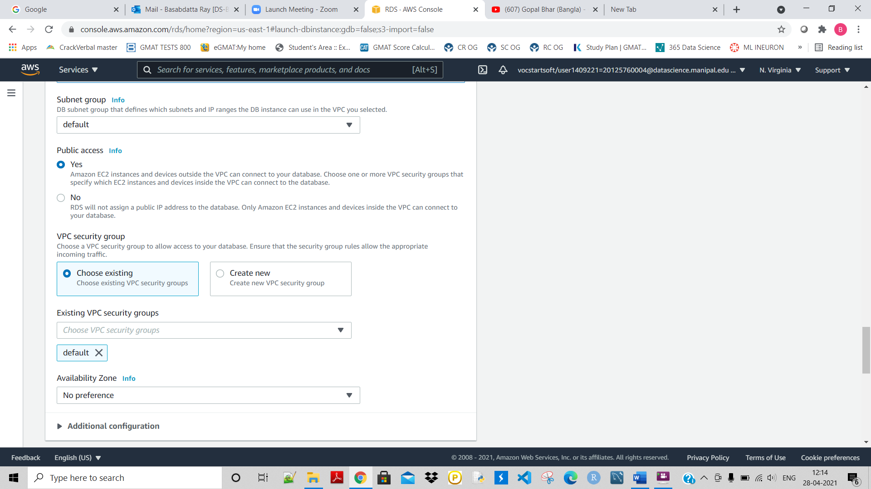

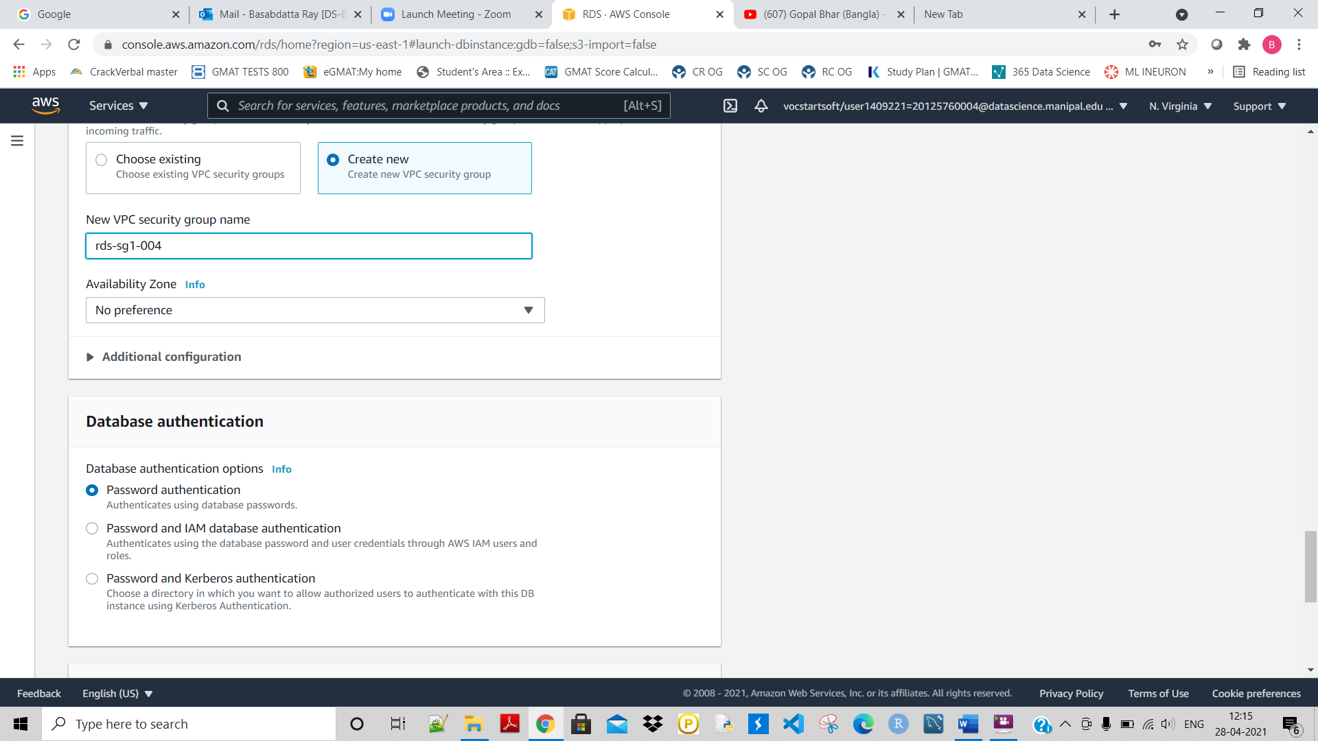

**Then click on create database:**

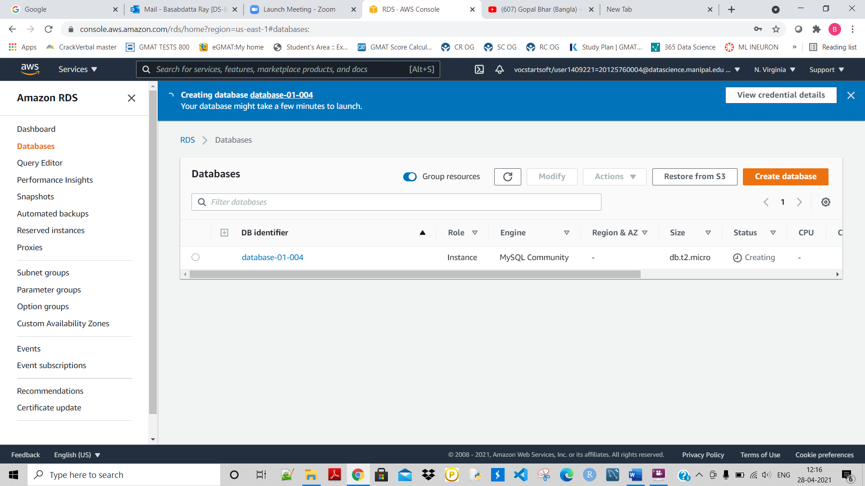

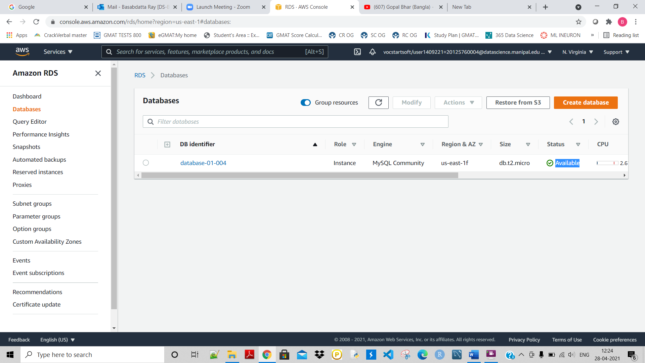

**Once it is created as shown above, let us connect to it:**

**GO TO MySQL Workbench:**

**Click on MySQL connections:**

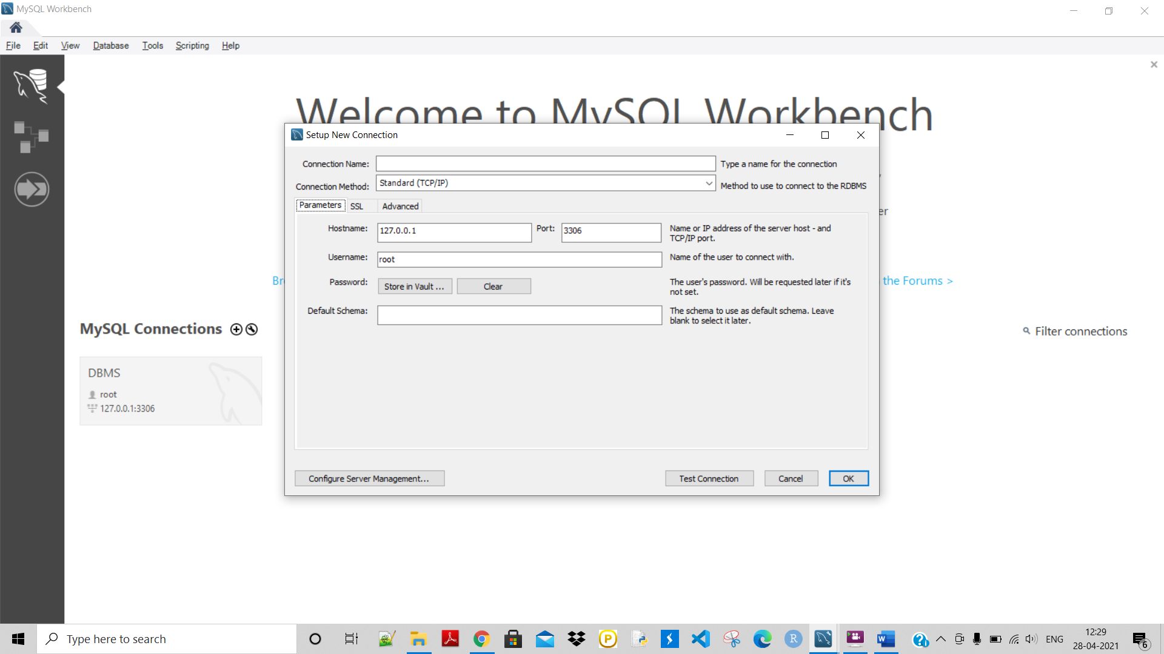

**And copy this from the db insctance:**

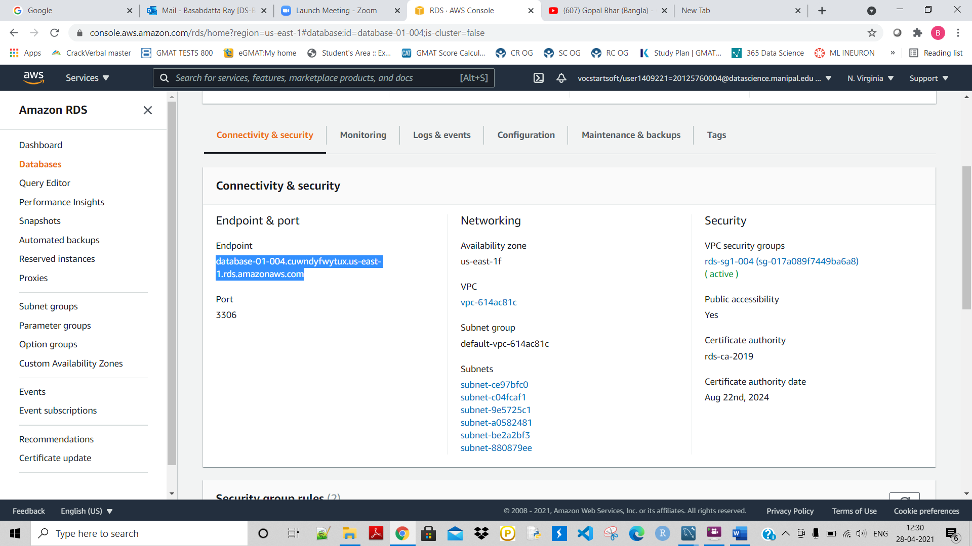

**And post this ‘**database-01-004.cuwndyfwytux.us-east-1.rds.amazonaws.com’ **as the Hostname in MySql, give username ‘admin’, give password ‘Admin1234’ and test the connection:**

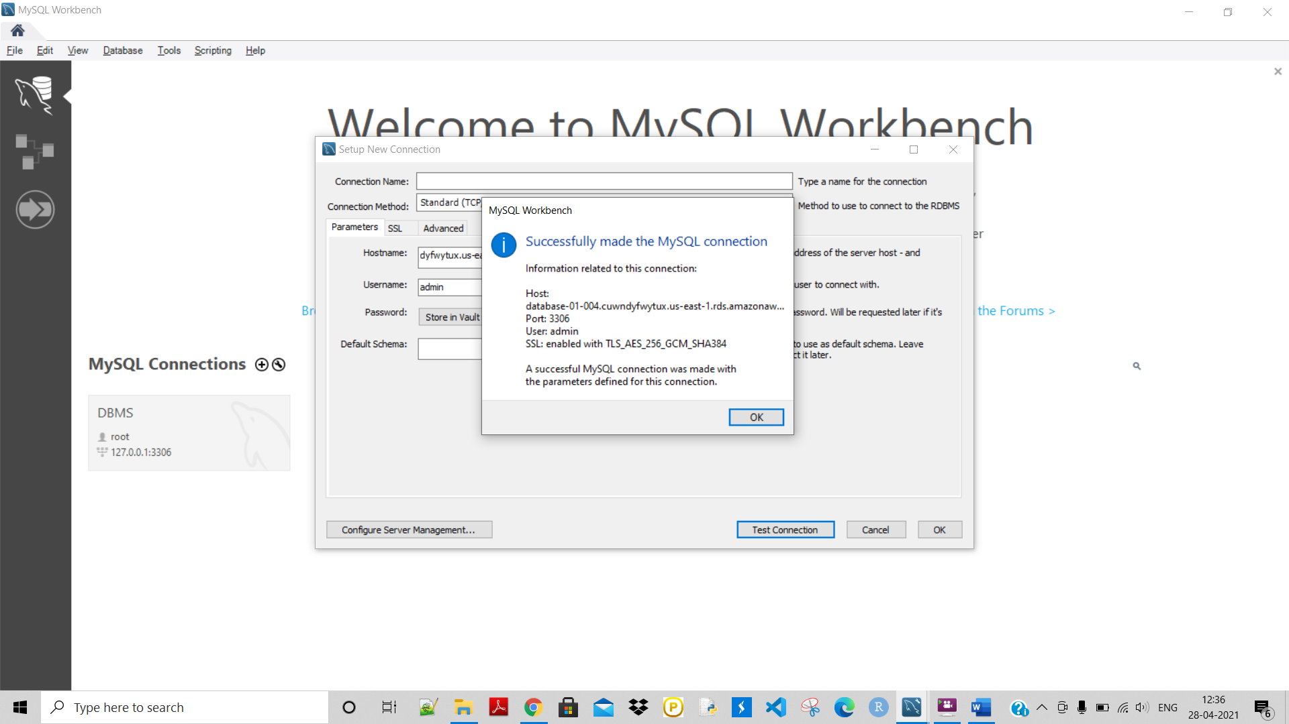

**So now connected with MySQL. Now give this RDS instance a name and open it :**

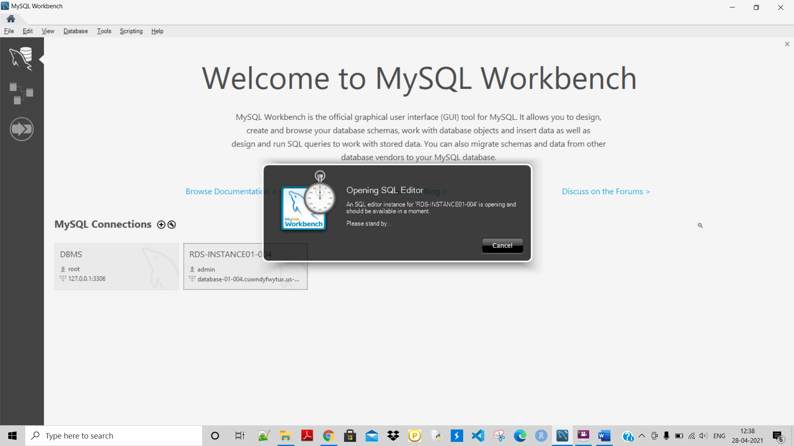

**Now created a DB inside this instance named ‘EMPLOYEEDB’.**

**Then created a table named ‘employees’ inside the DB.**

**Also inserted few employee records into the table.**

